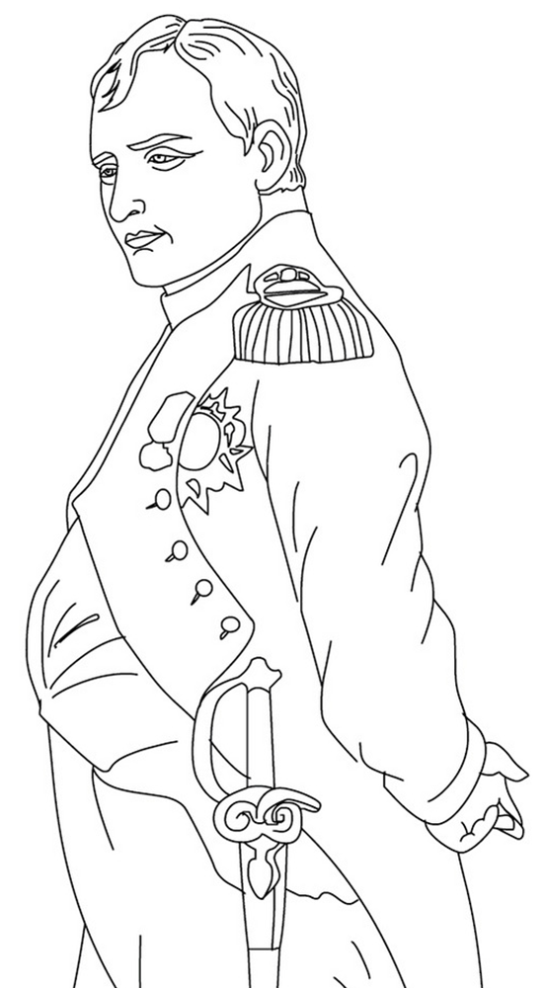
Napoleon and the End of the French Revolution

The Revolution
- People turn against Robespierre’s ____________________ from 1793-1794
- The _____________________ becomes the new government
- People lose _____________________________ in government
Napoleon
- Military _________________
- Rose rapidly through the military during the _____________________
- Suppressed a _____________________revolt in Paris
- Won every battle in campaigns in ___________________________
- Invaded ________________to weaken Great Britain
Napoleon Takes Power
- Staged a coordinated _____________________in 1799
- Named himself _____________________
- A _____________________ (vote by the people) approved his role
Military Feats
- Famously crossed the ____________ to surprise & defeat the Austrian army
- Occupied _____________________and appointed his brother, Joseph as King
- Conquers _____________________, Prussia, Portugal, & _____________________
- Attempts to unify _____________________under French rule
- Defeats repeated _____________________of European nations
- Uses the __________________________________to weaken England in war
Political Changes
- Crowns himself _____________________of France in 1804
- He wanted to lay the foundation for a future _______________________
- ____________________________ – simplifies laws for France
- Eliminates the __________________________________
- Allows freedom of ____________________ & improved ______________________

Defeats and Downfall
- __________________________ helped lead a slave rebellion in Saint-Domingue (Haiti)
- After his capture, Jean-Jacques ____________________ defeated French forces in 1803
- His Invasion of _________________in 1812 is a disaster
- In 1813, the _______________________ of European powers allied together
- The Coalition invaded ____________________ & occupied Paris
- Napoleon to ____________________ and go into exile on Elba
- French _______________________ was revived and given back the throne
Final Defeat
- Escapes for _________________
- Defeated again at _______________________ by the Seventh Coalition
- Exiled in prison on remote island of ____________________ in 1815 to live out his days

Napoleon and the End of the French Revolution
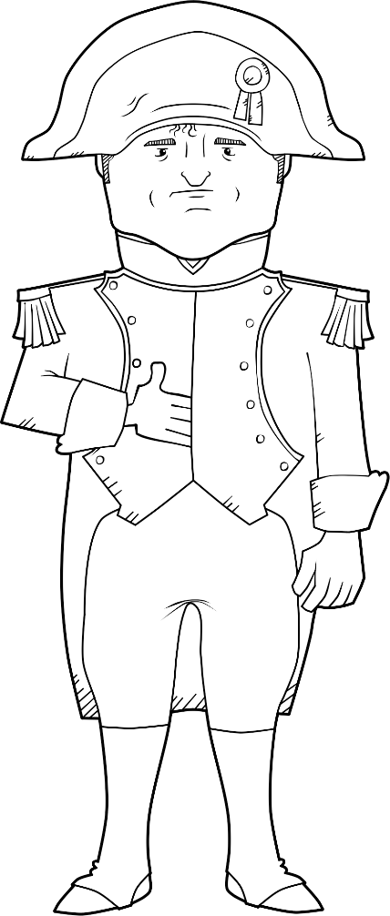 | The Revolution
 | Napoleon
 | Military Feats
 | Political Changes
 | Defeats & Downfall

